**Parking Sensor Project**

UW RGB Colour.wmf

**Department of Mechanical and Mechatronics Engineering**

**A Report Prepared For:**

The University of Waterloo

**Prepared By:**

Sanju Sathiyamoorthy

256 Phillip

150 University Ave W.

Waterloo, Ontario, N2N 2N2

Sept 19, 2022

256 Phillip St

150 University Ave W.

Waterloo, Ontario, N2N 2N2

September 19, 2022

Prof Andrew Kennings

Director, Mechatronics Engineering

Department of Mechanical and Mechatronics Engineering

University of Waterloo

200 University Ave W.

Waterloo, Ontario, N2L 3G1

Hello Professor,

This report is titled “Front Parking Sensor”, was prepared as my 2B work term report. I was having trouble when front parking my car and thought that if there was a way to know how close I was to the curb it would make parking a lot easier. This report highlights how I created a solution to this issue. It chronicles every step along the way from design to implementation and highlights the challenges I faced and the knowledge I gained along the way.

This report was written entirely by me and has not received any previous academic credit at this or any other institution. My role in this project was conducting all the research, designing the prototypes, and building the models.

Regards,

Sanju Sathiyamoorthy

20908541

2B Mechatronics Engineering

Table of Contents

List of Figures: ii

Summary iii

Introduction 1

1.1 Constraints & Criteria 1

1.2 Applicable Standards 1

1.3 Objective 1

Electrical 2

2.1 Background Information on Sensors 2

2.2 Engineering Analysis – Sensor Choice 2

2.3 Engineering Analysis – Output Method 3

2.4 Circuit Design 4

2.5 Code 8

Mechanical 9

3.0 Mechanical Design Constraints 9

3.1 Engineering Analysis - Mechanical Design 11

3.2 Engineering Analysis - Material Analysis 13

Conclusion 15

3.1 Limitations & Improvements 15

3.2 Applications 16

3.3 The future of Sensor Technology 16

3.4 Conclusions 16

References: 17

# List of Figures:

Figure 1: Circuit Design in tinker Cad 7

Figure 2: Working Circuit with Battery 8

Figure 3: Car Front Bumper and Curb 10

Figure 4: Top View Schematic 10

Figure 5: Final Design with Sliding Lid Isometric View 11

Figure 6: Final Design Top View 12

Figure 7: Sample Stress Strain Curve 14

Figure 8: First 3D print test 14

# Summary

The problem that this project was inspired by was in the difficulty of front parking in an older car model. There are no indicators to let the individual know the car is about to hit the curb. The constraints of this solution were that it should not hinder the driver’s experience when driving and should not interfere with the car’s function. The object of the report is to chronicle and outline the full procedure in which this solution was implemented. It aims to give insight into every aspect of the solution from concept to implementation. It will focus mainly on the electrical and mechanical aspect of the solution and show the research used to justify the decisions made throughout. Firstly, research was done on existing sensors and solutions for this problem and an ultrasonic sensor was chosen for use. Next the output of the system was chosen to be an LED to communicate the impending collision. The circuit design consisted of an Arduino UNO, breadboard and ultrasonic sensor connected to detect the curb and turn on the LED. The code for the Arduino was written such that the LED would only turn on when the sensor detected it within a certain distance. To house the circuit a physical casing would have to be designed to contain everything and hold it under the car’s front bumper. This design would have to adhere to a set of constraints to not interfere with the driving while also being secure. The material that was chosen for 3D printing was PLA due to its decent yield strength, hardness, and cheap cost. The applications of this project were in industrial contexts on conveyor belts. If products were out of place on the belt, the sensors could detect this and stop it. The developments of sensor technology have massive implications in the automobile industry and will help with the development of autonomous cars as better sensors mean a better awareness of the car’s surroundings. The limitations of this project and its room for growth lies in the wired LED connection as well as the adhesive to hold the device suspended under the front bumper. A wire going up to the side rear view mirror with the LED is not very clean and a wireless Bluetooth solution would be a lot simpler. Also, the device is held by adhesive and suspended below the car which could fall off when driving. The device’s weight and height could be decreased to make it more aerodynamic and less likely to fall. Another solution is to mount it mechanically using fasteners or hooks as opposed to adhesively. Although there is always room to improve for future iterations, the solution works according to the initial criteria and the project can be labelled a success.

# Introduction

When one is parking their car from the front (not reverse) it can be difficult to see where the front bumper is relative to the curb. This can make parking more stressful as well as difficult. If there was some way to know how close the curb was to the bumper it would make parking a lot easier and less stressful.

## 1.1 Constraints & Criteria

The constraints of this technical solution are that it should not hinder the driver’s experience in any way. This means it should not get in the way of the driving, parking, or anything else the driver would normally do. It should be a solution that seamlessly functions with the car itself and does not inconvenience the driver or create any new issues. This means the solution must consider the driver’s field of view when driving and not obstruct any moving parts of the car such as the tires or steering wheel.

## 1.2 Applicable Standards

The standards for the solution are not very specific as the driver must simply be able to park comfortably without hitting the curb. Normally, one would park about 1-2 feet in front of the curb. Using this number, the driver should be alerted at the very least one foot from the curb, so the driver has some time to react and stop the car. The error for this measurement should be at most ± 3 inches, as too much of an error can potentially lead to a crash.

## 1.3 Objective

The objective of this report is to explain and outline all aspects of the creation & implementation of this solution to the given problem. The report will give insight into all the challenges faced and decisions that were made along the way. The report will be written following the steps of implementing this solution from scratch and hence engineering analysis and judgement will be shown throughout the process as opposed to one specific section.

# Electrical

## 2.1 Background Information on Sensors

Currently there are a variety of cars that have considered this issue and solved it in a variety of methods. Many popular car’s use some sort of a proximity sensor that indicates when the car is within a certain distance to the curb. These proximity sensor systems have a variety of names such as park distance control, park assist, smart park, or many other names. There are two main types of parking sensors used. These two sensors are the ultrasonic parking sensor and the electromagnetic parking sensor.

## 2.2 Engineering Analysis – Sensor Choice

Ultrasonic sensors work by sending out high frequency sound waves. These waves hit off objects and are sent back which is received by the receiver. Ultrasonic waves are mechanical waves meaning they travel through air and create vibrations. The distance is then calculated through the time it took for the receiver to receive the signal after it was sent by the transmitter. [1] Some advantages of the ultrasonic sensor are that since it is a sound wave, the color is irrelevant. This means that even transparent objects can be seen without issue by the sensor. This also means that light does not have any influence so they can function just as well at night and low light environments. Some limitations of the sensor are in situations where other objects come in the path of the sensor such as rain and dirt. This means that they do not work as accurately under water. [2] Lastly and most relevantly, is the range. Many cheap sensors have ranges of only a couple meters, but the more expensive options can reach much further.

Electromagnetic sensors use an electromagnetic frequency to detect objects. Unlike ultrasonic waves, electronic magnetic waves are not mechanical meaning they do not need to travel through a material medium. These waves are created by charged particles that carry energy in the direction of the propagation. [3] This means that EM waves can travel through liquid, solid and air. EM sensors can be mounted inside of the car as the waves can pass through. This cuts down on most of the ultrasonic sensor limitations such as water, dirt while also being hidden making it more aesthetic. [1] The main limitation of electromagnetic sensors however is in the cost. On average EM sensors are much more expensive than ultrasonic ones.

The sensor that was chosen was the ultrasonic sensor due to its price and mainly the electromagnetic sensor being overkill for the goals of this project. The specific sensor chosen for the project was the HC-SRO4 ultrasonic range finder sensor.

## 2.3 Engineering Analysis – Output Method

After doing preliminary research on this field and existing solutions in the market, the solution type that was chosen was that of an ultrasonic sensor. The sensor would generate an input to the system and the output should communicate this information to the driver in some way. Figuring this which was the first challenge. After doing some research these were simple ways to output the information to the driver:

The first method was through an LCD display. LCD displays or liquid crystal displays is a type of flat panel display that uses liquid crystals. The LCD has many pixels that are turned on or off electronically through rotated polarized light. [4] The LCD that was cheapest while still being suitable for the project was the “DAOKI IIC Serial 2004 20x4 LCD Module” and would need 4 wires attached to it while also costing $16. With an LCD display the output of the system could be the distance from the ultrasonic sensor to the curb as a numeric value. The driver would conveniently be able to know exactly how far he was from the curb (to the accuracy of the ultrasonic sensor) if he could view the LCD display. Furthermore, to use the LCD a potentiometer would be needed in the circuit as well which was another disadvantage.

The second method was through an LED which stands for light emitting diode. LED’s function when a current is passed through it which lights up the LED through a microchip. [5] LEDs are far more efficient than normal incandescent light sources. This is due to the fact that incandescent light bulbs convert electrical energy into heat energy and then into light energy. LED’s make the process simpler by converting electrical energy immediately into light energy. [5] The plus side of the LED however is that a simple LED such as the “King bright WP15031D RED LED” is very cheap and would only need one connection for input and output as opposed to the 4 for the LCD. This means it could be integrated into the circuit much easier and it also only a couple cents to purchase as opposed to $16. However, since LED’s do not have pixels and instead work using an input current, this means they cannot display a numerical value like the LCD display could. This means that the LED would have to be programmed to turn on when the curb is within a certain distance as opposed to a constant number output. This is still okay as the goal of the project is to assist in parking and prevent curb collisions which this output solution would still do.

## 2.4 Circuit Design

After weighing out both options, the LED was chosen as the method of output for the first iteration of the solution due to its simplicity and cost. The next challenge was designing an electrical system such that the input could be converted into the output. For the logic of the system a microcontroller of some sort would be needed.

Microcontrollers are integrated circuit (IC) devices that can be used to control other electronic systems. This is typically done through the microprocessor unit, memory and sometimes more units. Microcontrollers are made to be responsive and quick with embedded system applications. [6] This means that they are ideal to interface with any electromechanical components or in our case simple an LED. The microcontroller that was chosen for the project was the Arduino UNO R3 due to its price and accessibility of access. It is a relatively basic yet reliable Arduino microcontroller that would be more than capable for the job.

The only constraints and requirements regarding the design of the circuit are that it cannot be too bulky, and the LED must clearly turn on when the ultrasonic sensor detects something within a certain distance. These constraints would not change much in terms of the design of the circuit which was found online [6] and is shown below on tinker CAD (See Fig. 1).

The main components of the circuit consist of the Arduino R3 UNO which acts are the brain of the system and handles the logic. The logic in this case is turning on the LED when the curb is within a certain distance from the front bumper. Let that distance be Y for now as more engineering analysis needs to be done before concluding a specific value. The logic for the circuit consists of a simple calculation to determine the distance. The ultrasonic sensor returns an input of a time as opposed a distance. The transmitter emits 8 pulses of 40 kHz and the time it takes to return to the receiver is output in microseconds (μs). [7] Let this value be T. In order to convert this value to a distance, the time can be multiplied by the speed of the pulse which is the speed of light. (0.034 cm/s) (see eqn. 1). However, since the time output is the time for the wave to hit the curb and bounce back, it is twice the measurement needed, hence this value can subsequently be divided by 2 again as shown below.

$$\begin{aligned}Distance =speed x time \#\left(1\right)\end{aligned}$$

$$D_{curb} =\frac{speed of wave x time}{2}$$

$$D_{curb}=\frac{0.034 \left(\frac{cm}{μs}\right) x T\left(μs\right)}{2}$$

The other main component of the circuit is the breadboard which contains everything in the circuit such as the resistors, LED, and the ultrasonic sensor. (see fig. 1) A breadboard is a simple device that allows for circuit creation without the need for soldering. Soldering is a joining method used to connect electronic components to a circuit board through melting an alloy. Breadboards let us circumvent this process and are a good starting point for electrical projects like this one. [8] Note that in fig. 1, the LED is connected to the breadboard itself. In the real implementation a long wire would be used to extend from the circuit to somewhere in the driver’s field of view such as the left rear-view mirror. The HC-SR04 sensor has 4 pins that are connected via circuit wires. The GND terminal is connected to the GND port of the Arduino in black which establishes a common ground for the circuit and sensor. The ground acts as a relative reference point for all the other voltages in the circuit. The Vcc terminal in the sensor provides the power for the sensor to operate and this is provided by the 5V port in the Arduino which is shown by the red wire. The Arduino itself gets it power from the power port that is shown in the top right of the Arduino. This can be plugged into a 9V battery to power the whole circuit. (see fig. 2) The trig pin of the HC-SR04 sensor is used to trigger the 8 ultrasonic sound pulses of 40kHz. To trigger the pulses this pin must be set on HIGH for 10 μs. [7] This pin is connected to port #13 on the microcontroller as seen by the orange wire in fig. 1. Note that this port number is arbitrary and regardless of what port is chosen it must be initialized in the Arduino code. The echo pin on the sensor is set to high as soon as the ultrasonic pulse is sent out. When the receiver receives the echo, it turns the echo pin to low. The duration is calculated by the time in which the echo pin stays high. [7] It is also important to note that if the receiver does not receive the echo within 38 ms it is automatically turned low. This means that the ultrasonic sensor only has a range of about 4m which is more than enough for the purposes of this project. The echo pin is connected to the 12 ports on the Arduino shown with the yellow wire in fig. 1. Port 11 on the Arduino is responsible for lighting up the LED as shown by its connection with the green wire. When the distance is within the given range, port 11 is set to HIGH and current flows into the LED. This current continues into the resistor and subsequently back into the ground port shown by the black wire in fig. 1. The resistor is connected in series with the LED which means that by increasing the resistor value the current decreases due to Ohm’s law as seen in eqn. 2:

$$\begin{aligned}V=I x R \#\left(2\right)\end{aligned}$$

Where V is voltage (V), I is current (A) and R is resistance ($Ω$). The resistor had a value of 1 k $Ω$. The circuit orientation and design in fig. 1 was chosen specifically to efficiently house the different components. The fully built circuit can be seen in fig. 2.

Figure 1: Circuit Design in tinker Cad

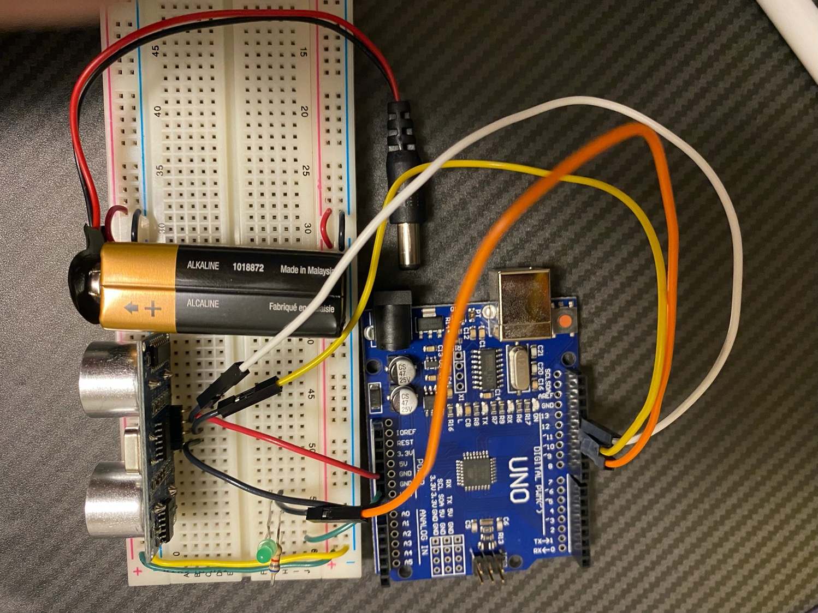

Figure 2: Working Circuit with Battery

## 2.5 Code

The only remaining part was to create the logic for this system which was mostly explained before. The code can be split into 2 major parts: the setup and the loop function. The setup contains all the initial configurations of the ports and variables to establish all the connections. This includes defining pin’s 11, 12 and 13 as the LED, echo, and trig pins as either input or outputs. The LED and trig pin are outputs as they are used to turn on the LED or trigger the pulse in the HC-SR04 transmitter. The echo pin is set to input as that value is returned by the receiver to signal the pulse has returned. In the loop function nothing is returned while it loops on forever. It starts by setting the trig pin to HIGH for 10 μs to send out the pulse. It then calculates the distance of the object using the time taken for the echo pin to turn LOW using equation 1. The final part is a simple if statement that checks if the distance is within a certain value and if so, turns the LED pin to HIGH to light up the LED and the function ends and loops.

# Mechanical

## 3.0 Mechanical Design Constraints

The next challenge was to design a physical product that could house the entire electrical system. This design would have to be constructed in a way that it could be put under the front bumper of the car and allow for the sensor to be positioned in a way that it has a straight view of the curb. Some constraints of this design are as following:

1. Sensor must be parallel to ground, so it has a level view of the curb. (See fig. 3)
2. Sensor must be at an appropriate height at which it can detect the curb. (See fig. 3)
3. The electrical system must be secure and not fall or move while the car is in motion.
4. The electrical system must not be exposed to the outside for debris to hit it while the car is in motion.
5. The electrical components should be able to be retrieved from under the car bumper with ease for any modifications or alterations. (Must be removable from car).
6. Should not hit the ground or obstruct driving of the car in any way.
7. The design should facilitate any modifications of the circuit without having to remove everything all the parts.

With a long set of constraints, designing an appropriate housing for the circuitry would be difficult and proved to be the most difficult engineering challenge so far.

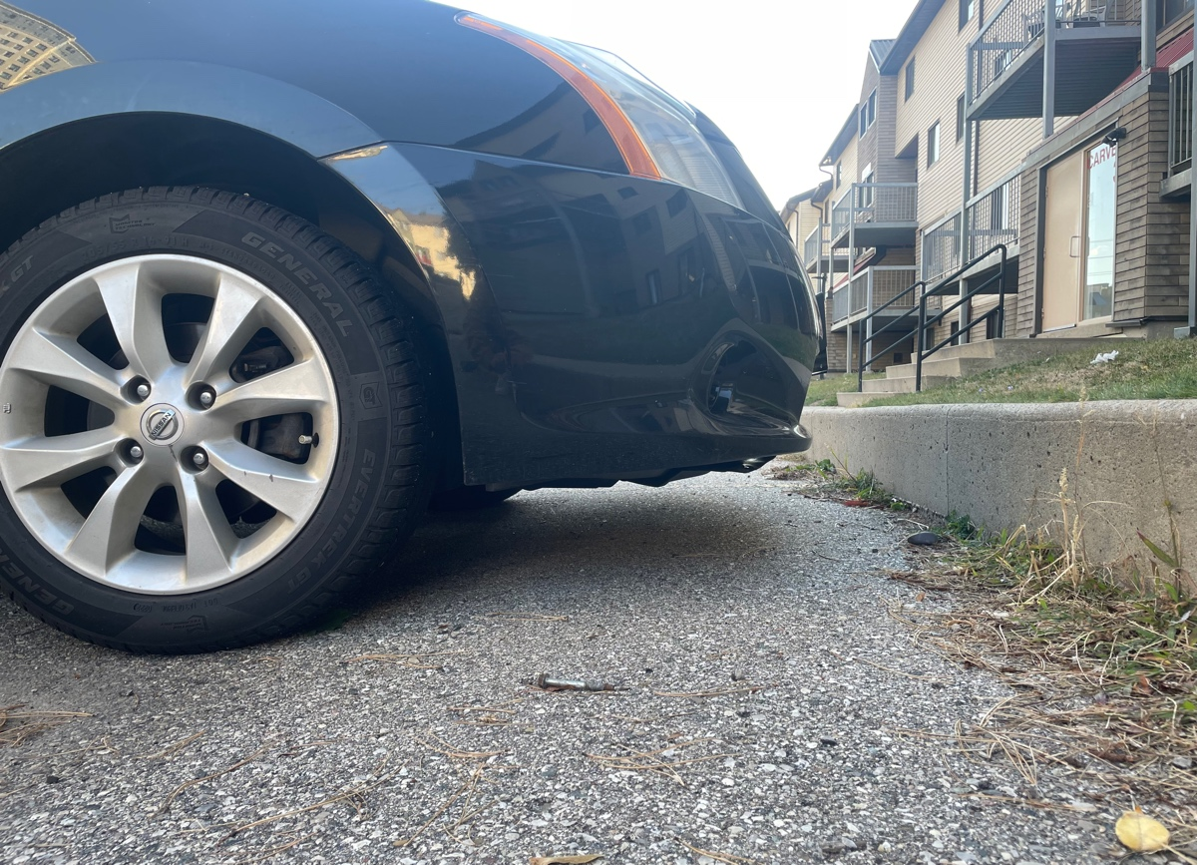

Figure 3: Car Front Bumper and Curb

Figure 4: Top View Schematic

## 3.1 Engineering Analysis - Mechanical Design

The challenge of this design was in the optimal way to house the parts relative to each other as well as figuring out how to attach the design to the bumper of the car while still being removable. Initial brainstorming led to ideas in which the design was mounted to the car in some way with a detachable mechanism. The front bumper of the car that was available for testing did not have anything to mount on however and the solution ideally had to work for as many vehicles as possible. Another solution was to attach the housing of the circuit to the bumper using an adhesive of some sort. This way it could be fit onto any car and would not be intrusive or damage the car in any way. The problem with this solution however was that it could not be removed easily as it would wear down the adhesive and the user could not use a new adhesive every time. This problem could be solved by having a detachable component that could detach from the part that was stuck to the bumper of the car. This way the detachable component could house the entire electrical system and the other piece could remain fixed to the bumper and they could fit with each other. This final design and mockup can be seen in fig. 4 and 5 respectively.

Figure 5: Final Design with Sliding Lid Isometric View

Figure 6: Final Design Top View

The white part acts as a lid of sorts to simply cover the top of the product and will be attached adhesively to the bottom of the front bumper of the car. The bottom part (grey) can slide into the lid component and hence be attached to the bumper and detached when needed for upgrades. The top view of the product can be seen in fig. 6. This part essentially just houses all the circuit components. The top right space is for the Arduino and there would be a cutout on the side for the usb port of the Arduino. This allows for new code to be uploaded to the Arduino without having to remove it from the physical casing as specified by the 7th constraint. Furthermore, the battery pack would sit in the center bottom compartment seen in fig. 6. This wire would follow the path around the bottom left corner and attach to the battery port in the Arduino to power the entire circuit. Lastly at the bottom right is the breadboard space. (See fig. 6) It is made to fit the size of a breadboard mini as a bigger breadboard is not needed and would be a waste of space and weight. It is important to note that the compartment sizes are specifically made for the components they house and prevent any movement of these parts while the car is in motion as per the third constraint. The sensor would be connected to the breadboard and should not be exposed as it can be damaged by debris while driving. That is what the 2 large circle cutouts are for seen in fig. 5. This exposes only the transmitter and receiver heads of the sensor and nothing else. The other circular cutout on the right face of fig. 5 is for the LED. A long wire would be used in the circuit for the LED and this wire would be fed through that opening and wrap around the side of the car until the driver’s side rear view mirror. The LED would be secured on this side mirror and can hence light up easily in the driver’s field of view.

## 3.2 Engineering Analysis - Material Analysis

The material that was chosen for 3D printing the design was PLA or polylactic acid which is a relatively common printing material due to it not requiring a heating bed and its ability to be printed at low temperatures. [9] In order to decide the material of use, the factors at play need to be considered. Since the product would be suspended underneath the front bumper of the car, it may be hit with debris such as small rocks and dirt. This means that the material needs to be somewhat durable enough to withstand this over time. Furthermore, since the product will be suspended with an adhesive of some sort, the heavier it is the greater the chance of it falling. This means that they weight must be considered and cannot be too heavy. Lastly, in case it does fall and hit the ground, the impact must not break the product and the internal circuitry should be intact. This means that the material must have a decent yield strength while also not being too brittle. Yield strength or tensile strength is the ultimate strength of a material and signifies how much load it can take before breaking. [10] The second requirement of it not being too brittle refers to the elasticity of the material which is the tendency to stretch under tension. Highly brittle materials such as diamond or glass are not prone to any bending or stretching when subjected to a load. The material property that determines the elasticity of it, is the young’s modulus. This is shown as the value of the slope in the stress-strain curve shown in fig. 7 below. This relationship models how the stress relates to the displacement of the material. This means that a higher young’s modulus value or a steeper slope means less strain per stress meaning a more brittle material. [10]. In our case PLA has a young’s modulus of about 4.17 GPa which is higher than some printing materials but an acceptable amount of brittleness for our purposes. This is ideal as the product should not break and shatter upon impact (if it falls) which would expose all the internal circuitry and likely break it. The first iteration of the product printed with PLA can be seen in fig. 8. Note that the printed version is slightly different from the final solid works designs (see fig. 5 and 6) as the print was a basic first iteration to test the 3D printing quality and material.

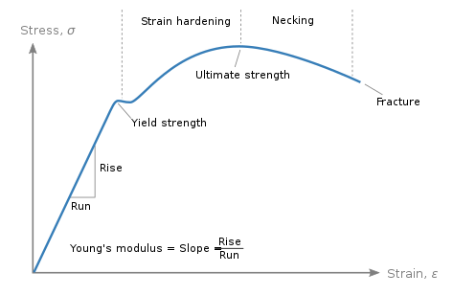

Figure 7: Sample Stress Strain Curve

Figure 8: First 3D print test

# Conclusion

## 3.1 Limitations & Improvements

The first limitation of this project is the adhesive used to connect the mechanical casing to the bottom of the car’s bumper. The reason for this is because adhesive wears down over time which means that it may fall off one day when driving. Another issue with this Is that if it falls off on the road it may hit another car behind it and cause an accident. Furthermore, if driving on the highway or somewhere fast the device may be lost and not recoverable. The best fix to this issue is to change the mode of attachment to the car. If there was some way to attach it using fasteners or hook it onto one of the car’s parts, it would be much safer and more reliable. The issue with this however is that each car is different and different models would have to be used for different car and an intrusive solution using fasteners may damage or leave marks on the car that some users may not be interested in. The other solution to this problem is to decrease the weight and height of the design. Decreasing the weight would make it lighter and less likely to fall off. Decreasing the height would make the device more aerodynamic as there will be a reduced surface area of contact with the air. This will also inadvertently reduce the weight.

The second limitation of this project is the method of communication to the driver. Having to use a long wire that extends out of the device from the bottom of the car to the side view mirror is inconvenient to set up and not an optimal solution. It leaves a wire visibly wrapping around the car that can make it unappealing. The easiest solution to this problem is to reduce the need for wires and create a wireless solution. In our current day everything is becoming wireless and implementing this would make the solution more seamless and modern. This could be done using a Bluetooth transceiver. A transceiver is similar to the ultrasonic sensor in the sense it can send out and receive signals. This way when the curb is senses instead of turning on the LED through a wired connection it could send a Bluetooth signal to the receiver in a separate circuit which could turn on the LED. This means two separate circuit components at the front bumper as well as somewhere in the car where the driver can see. This solution would look a lot cleaner but require another design to house the second circuit that could be mounted inside the car.

## 3.2 Applications

There are numerous applications to this project in any context when an individual could benefit with increased awareness of moving parts. This project can be extended to any older automobile vehicles such as buses, vans and more. Also, this can be helpful in industrial settings with forklifts or conveyor belts. Say for example if parts on the conveyor belt are out of line or simply not in their appropriate position, an ultrasonic sensor and LED could be used to alert workers who do not have a direct line of view. With forklifts, the driver may not be able to see Infront when carrying a big load and operating the vehicle is much more difficult. In this case the sensor could be hooked up to the front of the forklift with an LED at the steering wheel for collision indication.

## 3.3 The future of Sensor Technology

Currently, many of the top electric vehicles support some level of autonomous driving. This is entirely due to the advancement of sensors. These sensors give the car a sense of awareness of the surroundings which is used to drive the car. Currently there are not any cars that are fully autonomous but their use of advanced driver assistance systems (ADAS) help making driving a lot easier and safer using sensors. [11] Over time the precision and accuracy of sensors will increase and hence increase the car’s awareness of its surrounding will as well leading to the first fully autonomous car.

## 3.4 Conclusions

In conclusion this report has chronicled the steps taken to implement this solution from the initial problem to a working product. The report highlighted the electrical system used to communicate the information, the code that controlled the logic and finally the mechanical design to house and store everything. The final solution followed the initial criteria and stayed within the constraints of the solution. However, there are many ways the solution can be improved upon with more time and money. For future iterations of this product a Bluetooth communication system can be implemented to eliminate the need for clunky wires visible along the side of the car and the mechanical design can be improved to be more aerodynamic, light and eliminate the use of an adhesive. Although there is room for growth and these ideas can be implemented in the future, the solution still works according to the initial constraints and criteria and hence the project can be labelled a success.

# References:

[1] Ajeya, A. (2021, March 10). *Parking sensors : How do they work?* The GoMechanic Blog. Retrieved September 19, 2022, from https://gomechanic.in/blog/parking-sensors/

[2] Gross, K. (2020, October 28). *Ultrasonic sensors: Advantages and limitations*. MaxBotix Inc. Retrieved September 19, 2022, from https://www.maxbotix.com/articles/advantages-limitations-ultrasonic-sensors.htm/

[3] Admin. (2016, April 16). *Difference between sound waves and electromagnetic waves*. Pediaa.Com. Retrieved September 19, 2022, from https://pediaa.com/difference-between-sound-waves-and-electromagnetic-waves/

[4] Contributor, T. T. (2019, September 13). *What is LCD (liquid crystal display)?* WhatIs.com. Retrieved September 19, 2022, from https://www.techtarget.com/whatis/definition/LCD-liquid-crystal-display

[5] *Light emitting diode＜what are leds and how do they work?＞*. ROHM. (n.d.). Retrieved September 19, 2022, from https://www.rohm.com/electronics-basics/leds/what-are-leds

[6] *What is a microcontroller? the defining characteristics and architecture of a common component - technical articles*. All About Circuits. (n.d.). Retrieved September 19, 2022, from https://www.allaboutcircuits.com/technical-articles/what-is-a-microcontroller-introduction-component-characteristics-component/

[7] Last Minute Engineers. (2022, June 11). *How HC-SR04 ultrasonic sensor works & how to interface it with Arduino*. Last Minute Engineers. Retrieved September 19, 2022, from https://lastminuteengineers.com/arduino-sr04-ultrasonic-sensor-tutorial/

[8] Buckley, I. (2022, June 22). *What is a breadboard and how do you use one?* MUO. Retrieved September 19, 2022, from https://www.makeuseof.com/tag/what-is-breadboard/

[9] Simplify3D Software. (2019, June 27). *PLA*. All-In-One 3D Printing Software. Retrieved September 19, 2022, from https://www.simplify3d.com/support/materials-guide/pla/

[10] *How to choose the right 3D printing material*. Formlabs. (n.d.). Retrieved September 19, 2022, from https://formlabs.com/blog/how-to-choose-the-right-3D-printing-material/

[11] *How sensor technology will shape the cars of the future*. Melexis. (n.d.). Retrieved September 19, 2022, from https://www.melexis.com/en/tech-talks/how-sensor-technology-shape-cars-future